**KINGDOM OF SAUDI ARABIA**

|  |  |  |
| --- | --- | --- |
| **المملكة العربية السعودية**  **وزارة التعليم العالي**  **جامعة الإمام محمد بن سعود الإسلامية**  **كلية علوم الحاسب والمعلومات** | A description...  **Second term 1441/2020** | **KINGDOM OF SAUDI ARABIA**  **Ministry of Higher Education**  **Al-Imam Mohammad University**  **College of Computer & Information Sciences** |

**Software Engineering (CS- 310)**

**BSCS- Section: 171**

**Project-Phase No: 01**

**MADA verification**

**(SRS)**

**Submitted By**

**Abdulrahman Alghaligah (439015052) – Coordinator**

**Omair Aljabri (439012472)**

**Sulaiman Almohsen (439012196)**

**Omar Musayri (439011747)**

**Supervisor**

**Dr.Sultan S. Alqahtani**

**Date: 27,February**

1. **Introduction:**

This document gives a complete description of the SRS documents.

also provide purpose, list of definition, abbreviations and scope described clearly.

* 1. **Purpose**

purpose of this SRS documents is to cover all requirements for the “MADA Verifications” software, it will give also explanation of development of system, interfaces, interactions etc.

In the first place of this document is to give customer a clear image for this SRS document and his approval.

* 1. **Scope**

“MADA Verifications” is software system products will be mobile application of mobile Banking verification operations, which helps people to verify own bank operations easier and faster, currently is able to run on (Android) platforms and soon will be able also on IOS platform.

* 1. **Definitions, Acronyms, and Abbreviations**

|  |  |
| --- | --- |
| Term | Definitions |
| MV | Stands for MADA Verification application, which is a system to verify bank operations through mobile phones. |
| User | Client who’s using the MV application. |
| Application store | platform already installed on mobile phone as a store of applications can be downloaded either free or at a cost. |
| Stakeholder | Any person who’s benefits from the system and who is not a developer. |
| SRS | Stands for software requirements specification. |
| Face ID | Is a technology capable for identifying or verifying a person from a digital image. |
| Fingerprint | Is a technology capable for identifying or verifying a person from human finger. |
| OS | Stands for operating system. |

* 1. **References**
* Wikipedia: <https://en.wikipedia.org/wiki/Google_Play>
* Wikipedia: <https://en.wikipedia.org/wiki/Face_ID>
  1. **Overview:**

The second chapter of this SRS document gives an overview of the functionality of the product and describe the main functions that the system will do.

Third chapter …..

**2 General description:**

This section describes the general concept of our product and its requirements without going into details. The system will be explained how the product will communicate with other systems. It should be made those requirements easier to understand.

**2.1 Product perspective:**

The MV is a mobile application based. The application will be linked with banks systems. MV app will be used to verify banks operations while banks will make those operations, the bank will send a request to the app for verifying the operations. (see figure 1)

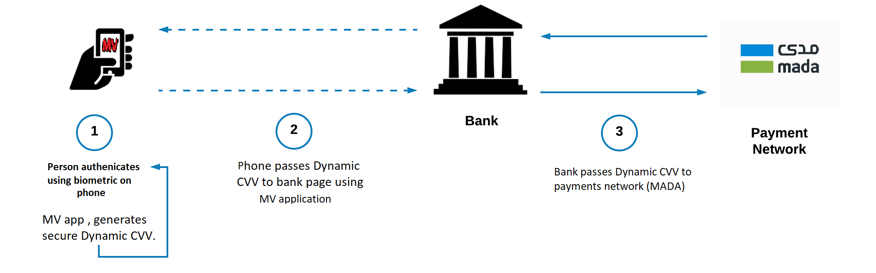

Figure : system overview

This figure explains the communicate between those systems, our application it will need somewhere to store the data, for that case we made MV database will only use to get data and modify data. All the databases communicate will go through internet.

**2.2 Product functions:**

The MV user can either add or remove banks cards to the application then he should link the card with his own face ID or fingerprint using them for verify operations also the app will be provide flexibility of adding or removing either fingerprint or face ID, also user can add his email for following his own operations. The application will be able to show card details and latest operations executed also the app will be provide complete privacy for these operations, and there are more and more settings can provide such as changing languages, allow notifications etc.

**2.3 User characteristics:**

The only user of the MV application is banks customer, a customer is anyone who has a bank account, the only skill needed by him is the ability to use smartphones further, he does not need to have a wide knowledge about technology. That means he should have simple knowledge.

**2.4 General constraints:**

At the beginning we planned to run our application on Android smartphones, so one of the constraints is our product only works on android OS. The App is run only on Google play platform which mean there are other constraints which is the app not able to run on IOS platform or Windows platform for now. The system is designed especially for those who have local bank account further, the app must have an internet access. The smartphones should support either face ID or fingerprint.

**3 Specific requirements:**

**3.1 Functional Requirements:**

Title

Function

Description

Input

Source

Output

Destination

Action

Requirements

Pre-Condition

Post-Condition

Side effect